**Various Parts of an Operating System**

UNIX and 'UNIX-like' operating systems (such as Linux) consist of a kernel and some system programs. There are also some application programs for doing work. The kernel is the heart of the operating system. In fact, it is often mistakenly considered to be the operating system itself, but it is not. An operating system provides many more services than a plain kernel.

It keeps track of files on the disk, starts programs and runs them concurrently, assigns memory and other resources to various processes, receives packets from and sends packets to the network, and so on. The kernel does very little by itself, but it provides tools with which all services can be built. It also prevents anyone from accessing the hardware directly, forcing everyone to use the tools it provides. This way the kernel provides some protection for users from each other. The tools provided by the kernel are used via system calls.

The system programs use the tools provided by the kernel to implement the various services required from an operating system. System programs, and all other programs, run `on top of the kernel', in what is called the user mode. The difference between system and application programs is one of intent: applications are intended for getting useful things done (or for playing, if it happens to be a game), whereas system programs are needed to get the system working. A word processor is an application; mount is a system program. The difference is often somewhat blurry, however, and is important only to compulsive categorizers.

An operating system can also contain compilers and their corresponding libraries (GCC and the C library in particular under Linux), although not all programming languages need be part of the operating system. Documentation, and sometimes even games, can also be part of it.

**Important parts of the kernel**

The Linux kernel consists of several important parts:

* Process management
* Memory management
* Hardware device drivers
* Filesystem drivers
* Network management
* Various other bits and pieces

**The following figure shows some of the more important parts of the Linux kernel**

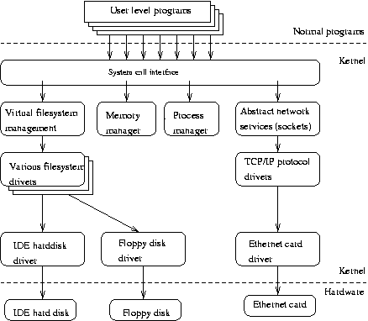

Probably the most important parts of the kernel (nothing else works without them) are memory management and process management. Memory management takes care of assigning memory areas and swap space areas to processes, parts of the kernel, and for the buffer cache. Process management creates processes, and implements multitasking by switching the active process on the processor.

At the lowest level, the kernel contains a hardware device driver for each kind of hardware it supports. Since the world is full of different kinds of hardware, the number of hardware device drivers is large. There are often many otherwise similar pieces of hardware that differ in how they are controlled by software. The similarities make it possible to have general classes of drivers that support similar operations; each member of the class has the same interface to the rest of the kernel but differs in what it needs to do to implement them. For example, all disk drivers look alike to the rest of the kernel, i.e., they all have operations like `initialize the drive', `read sector N', and `write sector N'.